**HTML | <tfoot> align Attribute**

Last Updated : 18 Feb, 2022

The**HTML <tfoot> align Attribute** is used to *set the horizontal alignment of text content inside the table footer (tfoot)*. It is not supported by HTML 5.

**Syntax:**

<tfoot align="left | right | center | justify | char">

**Attribute Value:**

* **left:** It sets the table footer text left-align.
* **right:** It sets the table footer text right-align.
* **center:** It sets the table footer text center-align. it has the default value.
* **justify:** It stretches the table footer text of paragraph to set the width of all lines equal.
* **char:** It sets the text-align to a specific character.

**Example:**

|  |
| --- |
| <!DOCTYPE html>  <html>    <head>      <title>          HTML tfoot align Attribute      </title>  </head>    <body>      <h1>GeeksforGeeks</h1>        <h2>HTML tfoot align Attribute</h2>        <table border="1" width="500">          <tr>              <th>NAME</th>              <th>AGE</th>              <th>SUBJECT</th>          </tr>            <tr>              <td>BITTU</td>              <td>22</td>              <td>CSE</td>          </tr>            <tfoot align="center">              <tr>                  <td>Name@123</td>                  <td>Age@123</td>                  <td>Branch@123</td>              </tr>          </tfoot>      </table>  </body>    </html> |

**Output:**  
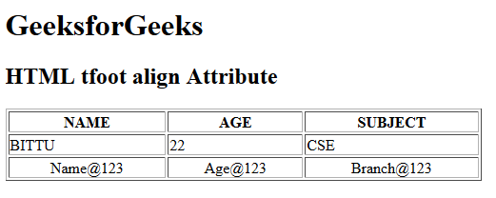

**Supported Browsers:** The browser supported by **HTML <tfoot> align attribute** are listed below:

* Google Chrome
* Internet Explorer
* Firefox
* Safari
* Opera